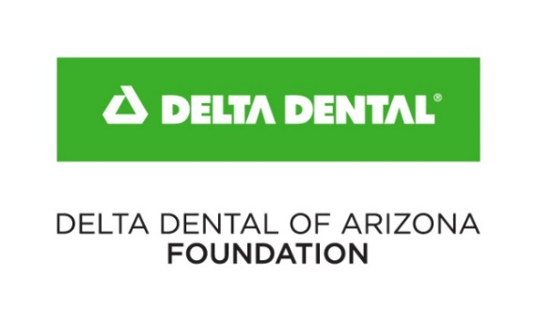
Donation Request – Grantee
Return completed form with Grant Application
Organizations within Maricopa County are expected to pick up their donation
Organizations are responsible for assembling Smile Bags from supplies provided
Smile Bag donations are limited to one request per organization per calendar year
For questions regarding supplies, contact Julie Roorda (jroorda@deltadentalaz.com | 602-588-3980
Contact Information
Organization Name: |  | Today’s Date:
EIN / Tax ID Number: | Website:
Address: |  | City: | Zip Code:
Requestor Name: |  | Requestor Title:
Requestor Phone: |  | Requestor Email Address:
Supplies Contact Name: |  | Supplies Contact Title:
Supplies Contact Phone: |  | Supplies Contact Email Address:

Donation Information
REQUESTED DATES MUST FALL WITHIN March 2023 — January 2024
Date items needed: | Requested pickup date: | Is this for an event?  Yes No | Complimentary shipping is available to organizations outside of Maricopa County
Will the supplies be used ONLY for grant activities?  Yes No (if no, please describe in detail below) |  |  | Ship to contact Ship to address below:
Additional activities/events where Smile Bags will be utilized (OTHER than grant program) – include quantities: |  |  | Name
 |  |  | Company
 |  |  | Address
Arizona County(ies) Served: |  |  | City, ZIP

Items and quantities requested |  | For Internal Use
Item Requested | Quantity | Qty pulled | Date Received: |  |  |  |  |  | Date Processed:
Infant Toothbrushes |  |  | Logged |  |  | Confirmed Pickup |  |  |  |  | Direct Delivery
Junior Toothbrushes (4–8 years) |  |  | Grant allotment: $ |  |  |  |  | Total Value of Donation: $
Youth Toothbrushes (8 years–Teen) |  |  | Notes:
Adult Toothbrushes
Youth Toothpaste
Adult Toothpaste
Floss
Bags
Education cards

5656 West Talavi Boulevard Glendale, AZ 85306 602-938-3131 www.deltadentalaz.com/foundation

